Iteration 3

# Process for Iteration 3

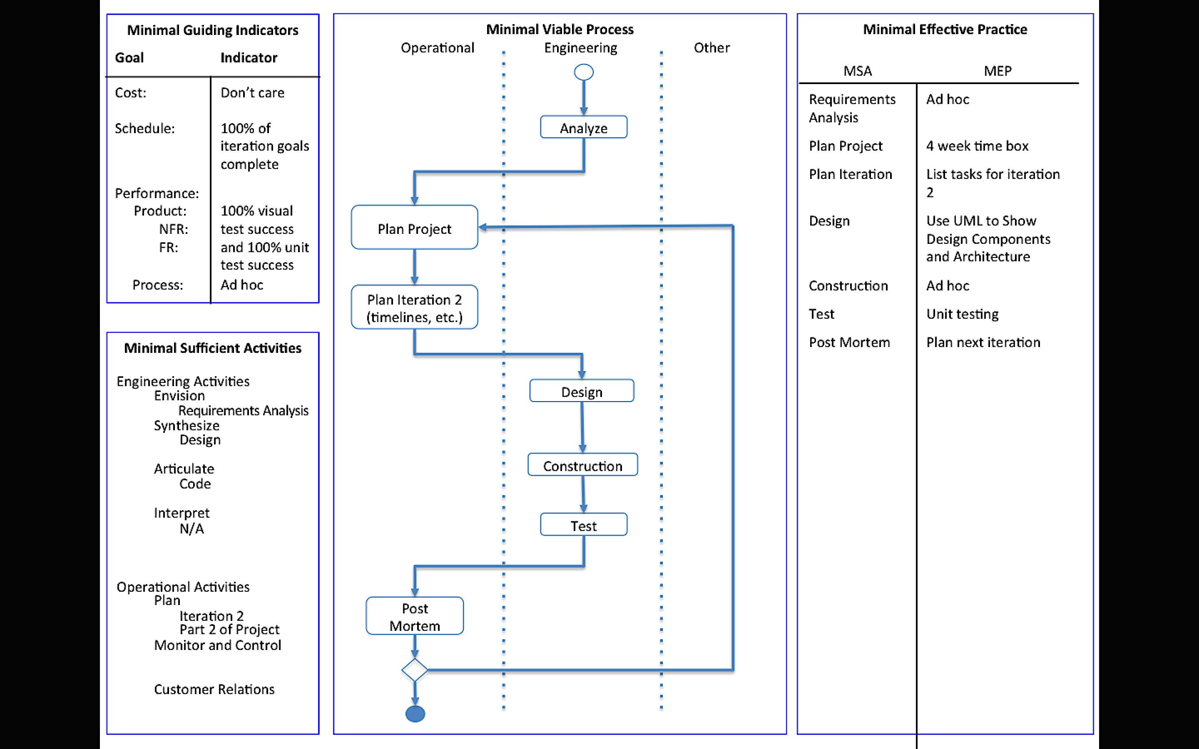

The process above has not been updated since Iteration 2.

# Requirements Analysis

The requirements have not changed since Iteration 1. They are as follows:

Given a secret image file and two innocent image files, the tool should

* Be able to read in image files and store the pixel information
* Use the extended visual cryptography scheme to encode the secret image pixels into the two innocent images
* Store the encoded images in new image files
  + The filenames and location can be specified by the user. If not, the files are named share1 and share2 and gets stored on the Desktop.

Given two encoded image files, the tool should

* Be able to read in the files and store the pixel information
* Use the extended visual cryptography scheme to decode the secret image from the encoded images (similar to super imposing them)
* The image revealing the secret gets stored in a new image file
  + The filename and location can be specified by the user. If not, the file is named secretMsg and gets stored on the Desktop.

The visual cryptography tool will only work with PNG and JPEG images. The images involved with the encoding process must have the same dimensions. The tool can handle images of any coloring.

# Plans for Project

Iteration 1:

* Create a graphical user interface
* Get the tool working for strictly black and white images
* Test the tool to check the quality of the encoded shares and the decoded message

Iteration 2:

* Research visual cryptography schemes with gray scale images

Iteration 3:

* Implement the visual cryptography scheme with grayscale images
* Add unit tests for the components of the visual cryptography tool
* Begin researching how to modify the current algorithm to handle color images

Iteration 4:

* Add the ability to encode and decode multicolor images

Iteration 5:

* Analyze the tool and look for ways to improve efficiency (performance and memory storage)
* Add features to project to help boost robustness (i.e. add in checks to keep the user from breaking the tool easily)

# Plans for Iteration 3

* Update the current cryptography scheme to improve the encryption and decryption of grayscale images
* Implement unit testing on the project’s components
* If time permits, begin researching and strategizing on how to update scheme to handle color images

# Design

Figure 1: UML Diagram from Iteration 1

Note, the design has not changed since Iteration 2.

Before changing the Java files to handle the gray scale images, I exported the PlantUML diagram of the visual cryptography tool. Figure 1 shows the class relations.

The research uncovered multiple ways of hiding gray scale images within other gray scale images. One technique utilizes several forms of visual cryptography. First, it breaks the secret image up into *n* shares. If those *n* shares were super imposed, then the secret image would be revealed. This first step is the visual cryptography scheme with pixel expansion. Then the innocent images need to be generated to have the same dimensions as the secret shares. Finally, you embed the secret shares into the generated images. To decrypt and reveal the secret image, you just have to superimpose the embedded shares. A second technique uses pixel expansion and error diffusing. Some other variations use dithering to group the pixels and treat them as strictly black and white images.

I plan on trying to merge multiple techniques. Since, I want to take the gray scale capabilities as a baby step towards using colored images, I need to look at methods that utilize the RGB values. I plan on taking the idea of breaking the secret image into secret shares to be embedded in the innocent images. As stated with the project requirements, my tool will only allow for two innocent shares. Hence, I only need to break the secret into two shares. That being the case, I propose grabbing the RGB value from the secret image and randomly splitting the gray concentration. With the image being gray scale, the red, green, and blue values will be the same. If the concentration was 128, then I would calculate a random number between 0 and 128 inclusive to be the gray concentration on the first secret share. The second secret share would be the original concentration minus the first share’s gray concentration.

As for embedding the shares with the innocent images, I plan on summing the gray concentrations of the two images into a new embedded image. I am unsure of how well this will work, so I may make adjustments while constructing based on the visual test results. Any changes will be documented in the construction portion.

For decrypting the secret message, I will initial try just adding the gray concentration of the two images. Depending on the visual test results, I may also try averaging the two concentration values. Again, changes and the reasoning for the changes will be discussed in the construction section.

# Construction

TBD

# Test

TBD

# Post Mortem

Since my time table for working on this project has been unorganized, in Iteration 4, I plan on adding in planning out the hours per day I plan on spending on the project. I will also monitor the actual time spent on the project. I began doing this during the fourth week of Iteration 3.

# Source Code

Not included since there was no change from Iteration 1.